View this in web layout mode to get the alignment right!!

**Car tires**

**Car seats and cribs**

**Caps and hats**

**Mattresses and pillows**

**Helmets**

**Whether item is important for safety interruptions**

**Whether hygiene is in question**

**Furniture (upholstered)**

**Guidelines for buying new vs. used**

**Whether hygiene is in question.**

**Whether item is important for safety interruptions**

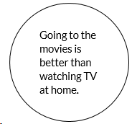

**Guidelines for buying new vs. used**

**Whether item   
is the same when new vs.   
 used**

**CD’s and DVD’s**

**Hand tools (hammers, wrenches)**

**Books**

**Whether hygiene is in question**

**Whether item is important for safety interruptions**

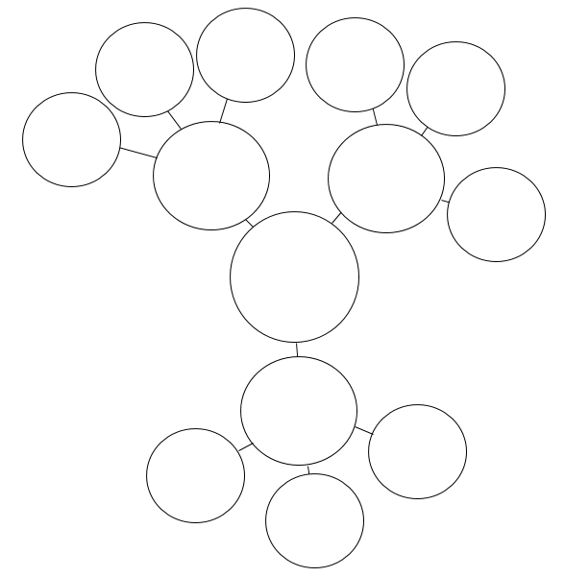

**Guidelines for buying new vs. used**

**Whether item   
is the same when new vs.   
 used**

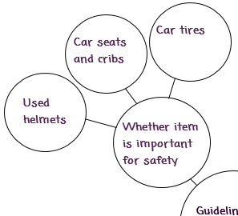 

**Helmets**

**Helmets**



**Your topic**